

**Frances Bacon Student of the Year Award**

Please answer the questions below to complete your nomination for consideration

by the selection committee.

|  |  |
| --- | --- |
| **YOUR FIRST AND LAST NAME** |  |
| **Your Job Title and Chimes Location** |  |
| **First and Last Name of Chimes School Student**  **you’re nominating** |  |

Explain why the nominee deserves the **Frances Bacon Student of the Year Award**, highlighting their **academic achievement, leadership and character, community engagement, resilience and overcoming adversity, and inspiration to peers.** Use the other side as well, if needed. If you’re completing this paper form, please submit at the designated area indicated by your supervisor.

|  |
| --- |
|  |
|  |
|  |
|  |
|  |

Instead of paper, you can nominate here: <https://forms.office.com/r/CSRGZuj29c>

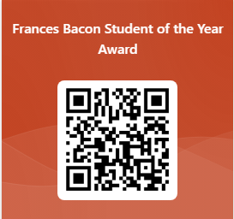Or here: