

**IDD Leader of the Year**

Please answer the questions below to complete your nomination for consideration

by the selection committee.

|  |  |
| --- | --- |
| **YOUR FIRST AND LAST NAME** |  |
| **Your Job Title and Chimes Location** |  |
| **First and Last Name of LEADER**  **you’re nominating** |  |

Explain why the above nominee deserves the **IDD Leader of the Year Award**, highlighting their **leadership excellence, quality of care, staff development and support, program innovation, collaboration, and communication skills**. Use the other side as well, if needed. If you’re completing this paper form, please submit at the designated area indicated by your supervisor.

|  |
| --- |
|  |
|  |
|  |
|  |
|  |

Instead of paper, you can nominate here: <https://forms.office.com/r/cHgWWBAHLG>

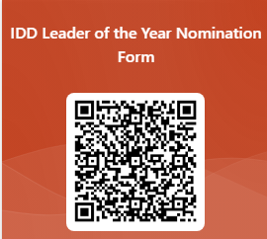Or here: